Rubest: reference manual
Table of Contents
Rubest: reference manual 1
Goals of Rubest program 2
Limitations for Rubest 2
Rubest operations' notation 3
Operations' implementation 3
Rationale of dropping combination invariants 3

Goals of Rubest program
As you probably know, there's a method of solving kube-rube (rubik's cube) by structural approach in three stages: you should solve kube-rube plane by plane. At the first stage, you solve any plane you want (plane of any color – orange on the pictures), then middle plane adjacent to the first (during that stage, you keep the first plane solved), and then the last plane (again, keeping previous two planes solved). The first stage is trivial, the second is affordable, but the last one is the most complicated. There are several specific combinations what fit to the requirements of the 3rd stage (keeping the rest two planes solved). Using them consequently, it's always possible to solve the last plane.
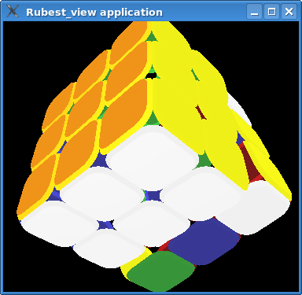Illustration 1: the result of the 2nd stage
Usually, combinations of the 3rd stage are quite long, so sequence of such combinations is even longer. It seems like we can find more optimal solution than only sequences of standard combinations. That's why we are doing such investigation.
We are NOT trying to find “God's numbers” for solving kube-rube in the least possible turns. Obviously, it's not the most optimal variant, but it's accessible for human. Once we've found some useful combination, we can use it in manual solving.
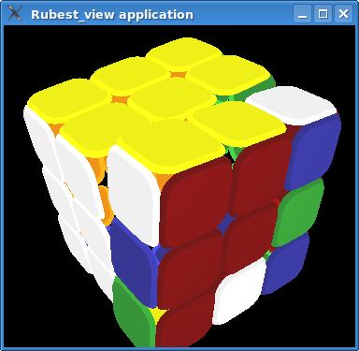Illustration 2: the result of the 2nd stage - unsolved last plane is vinous

Limitations for Rubest
We intend to run Rubest on regular workstation with no specific hardware like very-large disk storage, huge amount of RAM or large multi-processor platform.
- 1Gb of RAM should be sufficient for deepness of 9 turns
- Capacity of disk storage should be accessible for regular workstation
- Multi-processor platform should be used at most if available

Rubest operations' notation

Operations' implementation

Rationale of dropping combination invariants
Full brute force investigation doesn't meet our limitations. At least we need to filter this method to fit in available RAM memory.

